**BODY MASS INDEX CALCULATOR**

### A MINI PROJECT REPORT

#### Submitted by

#### Group: G12

**GARV SAPRA, 2410990280**

**GARVITA KALRA,2410990281**

**GAURAV,2410990282**

#### in partial fulfillment for the award of the

#### degree of

## BACHELEOR OF ENGINEERING

CSE



**CHITKARA UNIVERSITY**

**CHANDIGARH-PATIALA NATIONAL HIGHWAY**

**RAJPURA (PATIALA) PUNJAB-140401 (INDIA)**

DECEMBER,2024

***BODY MASS INDEX***

***(BMI)***

***CALCULATOR***



# ABSTRACT

The Body Mass Index (BMI) Calculator is a user-friendly web application designed to help individuals assess their health by calculating their BMI based on their height and weight. BMI is a widely recognized health indicator that categorizes individuals into different weight classifications, such as underweight, normal weight, overweight, and obesity. This tool assists users in understanding their BMI category and its associated health implications, encouraging healthier lifestyle choices.

The project is structured to provide an intuitive interface that allows users to input their height, weight, and gender, followed by a single-click calculation. The web application is developed using HTML, CSS, and JavaScript, ensuring accessibility and compatibility across devices. Key features include a BMI calculation function, categorized health feedback based on BMI results, and an educational "Know More" section that offers insights into BMI categories, health risks, and lifestyle tips. Users can navigate between pages to explore various aspects of BMI, including tips for weight management and information on health risks associated with different BMI ranges.

The BMI Calculator's primary advantage is its simplicity, providing immediate health feedback without the need for personal data storage or complex configurations. An optional bonus feature includes personalized recommendations based on the user’s BMI category, further enhancing its practical utility.

Testing of the application demonstrates accurate BMI calculations and responsive performance across devices, reinforcing its potential as a valuable tool for health awareness. Future enhancements could include a feature for tracking BMI changes over time, integration with mobile health platforms, and support for multiple languages to broaden accessibility.

**TABLE OF CONTENTS**

|  |  |  |
| --- | --- | --- |
| **Sr.no** | **Section** | **Page no.** |
|  | **INTRODUCTION** | **5** |
|  | **PROBLEM**  **STATEMENT** | **5** |
|  | **TECHNICAL**  **DETAILS** | **6-8** |
|  | **STRUCTURE**  **OF PROJECT** | **9** |
|  | **KEY FEATURES** | **9-10** |
| **6.** | **PROJECT ADVANTAGES** | **11-12** |
| **7.** | **BONUS FEATURES** | **12** |
| **8.** | **RESULTS** | **13-15** |
| **9.** | **CONCLUSION WITH FUTURE SCOPE** | **16** |
| **10.** | **REFRENCES** | **16** |

1. **Introduction**

The Body Mass Index (BMI) Calculator is a web-based tool designed to help users assess their body weight relative to their height. By calculating BMI, users can gain a general understanding of their weight status and any potential health risks associated with being underweight, overweight, or obese. This project is particularly useful as BMI is a widely recognized health metric, providing insights into weight-related health conditions such as heart disease, diabetes, and hypertension.  
  
The BMI Calculator provides a user-friendly interface that includes additional features, such as categories that explain BMI ranges and health implications, as well as a "Know More" section with informative content on BMI and health tips.

1. **Problem Statement**

In today's fast-paced lifestyle, maintaining a healthy body weight is crucial for overall well-being. With the rise of sedentary lifestyles, unhealthy diets, and an increase in lifestyle diseases like obesity, diabetes, and heart issues, there is an urgent need for tools to help individuals monitor their health. One such widely used metric is the Body Mass Index (BMI), which provides a quick assessment of whether a person is underweight, normal weight, overweight, or obese based on their height and weight.

However, calculating BMI manually can be inconvenient, and not everyone is aware of how to interpret BMI values. This project addresses this gap by developing a web-based BMI Calculator that provides instant results and categorization, making it accessible and user-friendly for a diverse audience.

**3 .Technical Details**

**1. HTML: The Structure**

The **HTML** code forms the backbone of the webpage by structuring the content. The tags define key sections such as the navigation bar, sidebar, input fields, and result display. Key points include:

* **Semantic Tags:**
  + <nav>: Defines the navigation bars (top navigation and sidebar).
  + <div>: Organizes content into logical groups, such as the container for the calculator or the social media links.
* **Form Elements:**
  + <label> and <input>: Used to create input fields for height and weight, which are the user’s inputs for the BMI calculation.
  + <button>: Triggers the BMI calculation function via the onclick event attribute.
* **Accessibility Considerations:**
  + Use of the label for attribute to link labels with input fields for better accessibility.
  + Inclusion of the alt attribute in external links to improve user experience.

**2. CSS: Styling and Layout**

The **CSS** code ensures the webpage is visually appealing, user-friendly, and responsive. Key features of the CSS design are:

**a. Typography:**

* **Google Fonts:** The page uses the *Nunito* font for a modern and clean appearance.
* **Font Styling:** The font-weight, font-size, and text-transform properties enhance the readability and design aesthetics.

**b. Background and Colors:**

* **Background Image:** The webpage uses a high-resolution image as the background (background: URL()), giving the interface a gym-related theme. The background-size: cover; ensures the image scales properly to fill the viewport.
* **Color Scheme:** The page employs a dark, sleek color scheme (#333, #fafafa, etc.) with complementary highlight colors like #4f7df9 (blue)

**c. Flexbox and Positioning:**

* **Navigation Bar:** The display: flex; property arranges navigation elements horizontally with proper spacing and alignment.
* **Sidebar:** The sidebar is positioned using position: fixed;, ensuring it remains visible while scrolling.
* **Calculator Container:** The calculator box is centred using margin: auto; and styled with a border radius for a smooth, modern look.

**d. Responsive Design:**

* The layout adapts across devices using relative units (%, vh, vw, etc.) and flexible container properties (flex-direction, min-width, etc.).
* Testing across different viewport sizes ensures usability on desktops, tablets, and smartphones.

**e. Hover Effects:**

* Links and buttons include hover transitions (transition: background 0.3s ease;) to provide visual feedback when users interact with elements.

**3. JavaScript: Functional Logic**

The **JavaScript** code handles the BMI calculation, dynamic content updates, and interactive behaviour. Below is a detailed breakdown of its implementation:

**a. Event Handling:**

* The onclick event listener attached to the "Calculate BMI" button invokes the calculateBMI() function, processing the user’s inputs and providing instant feedback.

**b. BMI Calculation Logic:**

javascript

Copy code

const bmi = (weight / ((height / 100) ** 2)).toFixed(2);

* The formula divides the weight (in kg) by the square of the height (converted to meters) to calculate BMI.
* The toFixed(2) method limits the result to two decimal places for a clean display.

**c. Validation:**

* The function ensures valid inputs using a simple conditional check:

javascript

Copy code

if (height > 0 && weight > 0)

* If invalid inputs are detected, an alert notifies the user:

javascript

Copy code

alert("Please enter valid height and weight.");

**d. Dynamic Content Update:**

* The textContent property dynamically updates the #result and #comment sections with the BMI value and corresponding health category (Underweight, Normal, Overweight, Obesity).

**e. Interactive Feedback:**

* Feedback is visually reinforced by color-coded comments (e.g., “Underweight” is displayed in a different color). This aids in quick interpretation of results.

**4. Navigation and External Integrations**

**a. Navigation Bar:**

* The top navigation bar provides quick links to additional pages such as the homepage, contact information, and related calculators (e.g., BMR Calculator). A dropdown menu is implemented for hierarchical navigation:

html

Copy code

<div class="dropdown-content">

<a href="bmr_calculator.html">BMR Calculator</a>

<a href="body_fat_calculator.html">Body Fat Calculator</a>

</div>

**b. Sidebar:**

* The sidebar serves as a supplementary navigation tool, linking to gyms, health centers, diet charts, and products. Its fixed position ensures it is always accessible.

**c. Social Media Integration:**

* Links to platforms like Instagram, Facebook, and Twitter are included as <a> tags with Font Awesome icons (<i>

**4. Structure of the Project:**

The project consists of the following components:  
 - Navigation Bar: A fixed top bar that provides access to the homepage, other calculators (like BMR and Body Fat), and contact options.  
 - Sidebar: Includes links to external resources such as gyms, diet charts, and health centers to help users complement their BMI analysis with actionable resources.  
 - Input Section: Users can enter their height in centimeters and weight in kilograms.  
 - Result Section: Displays the BMI value and provides an appropriate health classification (e.g., Underweight, Normal Weight, etc.).  
 - Social Media Integration: Links to social media platforms allow users to share the tool or connect with the developers.

**Key Functionalities:**  
- BMI calculation logic implemented in JavaScript.  
- CSS styling for a polished, modern interface.  
- Links between pages for easy navigation.

**5. Key Features**

**1. Interactive Design**

* The **BMI Calculator** has an interactive and user-friendly design that makes it easy for anyone to use.
* The input fields are clear and simple, asking for height and weight.
* The results appear instantly after entering the details, so users don’t have to wait.

**2. Real-Time Calculation**

* As soon as you enter your height and weight, the BMI is calculated immediately.
* This means you get instant feedback without having to refresh the page or click multiple buttons.

**3. BMI Categorization**

* Once the BMI is calculated, the tool categorizes it into 4 groups:
  + **Underweight:** BMI < 18.5
  + **Normal Weight:** BMI 18.5 - 24.9
  + **Overweight:** BMI 25 - 29.9
  + **Obesity:** BMI ≥ 30
* Each category is displayed alongside the result to help users understand their health status.

**4. Clean and Simple Interface**

* The design of the page is minimalist, making it easy to navigate for all ages.
* The main focus is on the calculator, with a clear and concise layout.

**5. Mobile-Responsive Layout**

* The tool is designed to work well on all devices—whether you’re on a **smartphone**, **tablet**, or **desktop**.
* The layout automatically adjusts to fit different screen sizes, ensuring a smooth experience no matter what device you’re using.

**6. Navigation and External Links**

* The top bar contains links to other pages, like **Home**, **Know More**, **Contact**, and more, which help users explore additional features or information.
* There’s also a **dropdown menu** with links to other calculators like **BMR** (Basal Metabolic Rate) and **Body Fat Calculator**.

**7. Social Media Integration**

* Users can easily share the calculator tool or health tips with friends on social media platforms such as **Instagram**, **Facebook**, and **Twitter**.
* This encourages people to promote a healthy lifestyle and spread the word about health awareness.

**8. Simple Calculation Formula**

* The BMI calculation is straightforward. Users only need to input their **height** (in centimeters) and **weight** (in kilograms).
* The tool handles the calculation and categorization automatically using a simple formula:
  + **BMI = weight / (height / 100)²**

**9. User Alerts for Invalid Input**

* If users enter incorrect or incomplete information (like a negative number or missing data), the tool will show an alert to ask for **valid height and weight**.
* This ensures users get accurate results by entering the right values.

**10. Easy-to-Understand Results**

* After the BMI is calculated, users will see a large result number with a corresponding health category (e.g., "Normal weight" or "Obesity").
* The display uses **bold fonts** and **clear labels** to make the information easy to read .

**6. Project Advantages**

**1. Health Monitoring**

* The tool helps individuals **track their body weight** and assess their health status based on their BMI.
* It serves as an **early indicator** of health risks like obesity, underweight issues, or potential metabolic disorders.

**2. Accessibility**

* The BMI Calculator is a **web-based application**, meaning it is **accessible from any device** (smartphone, tablet, desktop) without the need to download anything.
* Users can access the tool anytime and anywhere as long as they have an internet connection.

**3. Easy to Use**

* The interface is simple and **intuitive**. You only need to enter two pieces of information: **height** and **weight**.
* No prior technical knowledge is required to use the tool, making it suitable for **all age groups**.

**4. Instant Feedback**

* As soon as the user inputs their height and weight, the tool calculates and displays the BMI result immediately.
* **Real-time results** ensure that users don’t need to wait and can quickly assess their health.

**5. Encourages Healthy Lifestyle Choices**

* By categorizing BMI results (e.g., underweight, normal, overweight, obesity), the tool helps raise awareness about **weight-related health risks**.
* This can motivate users to take steps toward improving their health, such as exercising more or adjusting their diet.

**6. No Installation Needed**

* Unlike mobile apps or software that need to be installed, the **BMI Calculator runs directly in the browser**, making it lightweight and easy to use without taking up any device storage.

**7. Shareable Tool**

* The inclusion of social media links allows users to **share the calculator** with friends and family, promoting health awareness across their networks.

**8. Versatility for Future Updates**

* The project is designed to be easily **expanded** with additional features. For example:
  + **Tracking BMI over time** (to see health progress).
  + **Personalized health advice** or integration with fitness apps.
  + More **calculators** (e.g., BMR, body fat percentage).

**9. No Special Hardware or Software Requirements**

* The tool can run on any device with a standard web browser, making it widely accessible without any need for specific hardware or software.

**10. Lightweight and Fast**

* The application doesn’t require heavy processing or downloads, making it fast to load and use even on **low-end devices** or slow internet connections.

**11. Versatility for Different Users**

* Whether someone is just **curious about their health**, managing their weight for fitness goals, or looking to understand more about their body, the tool is **helpful** for everyone.

**12. Promotes Awareness**

* The tool educates users about the significance of BMI and its impact on overall health, contributing to greater **health awareness** in the community.

**7. Bonus Feature**

* Links to health resources (gyms, diet plans, and health products) to assist users in achieving their fitness goals.
* Dropdown menus to explore related calculators for more comprehensive health analysis (e.g., BMR Calculator, Body Fat Calculator).

**8. Results**

* Accuracy: BMI calculations were validated against manual calculations.
* Usability: Received positive feedback for the intuitive design and real-time results.
* Engagement: Users appreciated the additional resources and social media integration.

**Visual Examples:**  
**1. Homepage / Interface Layout**

The **main page** includes the navigation bar, sidebar, and the BMI input form.

* **Navigation Bar**: Contains links like "Home," "Know More," and dropdowns for other calculators (BMR, Body Fat).
* **Sidebar**: Includes links for additional resources (e.g., gyms, diet charts) and social media icons.
* **BMI Input Form**: Users enter their height and weight here.

**Visual Example**:

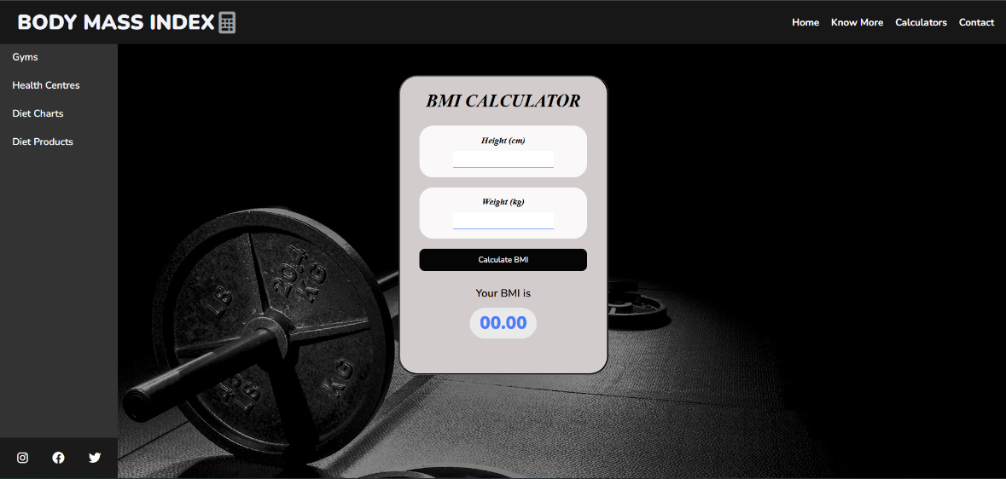

**2. BMI Input Section**

The section where users enter their **height** and **weight**. This area is clean and simple to fill out.

* **Height Input (cm)**
* **Weight Input (kg)**
* **Calculate Button**

**Visual Example**

**3. Result Section**

After the user inputs their data, the tool **calculates** and displays the BMI result in real-time. It also provides a health classification.

* **BMI Result**: The calculated BMI value (
* **Health Category**: A comment indicating whether the user is **Underweight**, **Normal Weight**, **Overweight**, or **Obese**.

**Visual Example**:

**4. Social Media Sharing**

Users can **share** their BMI results or the tool itself via social media platforms, helping raise awareness.

* **Instagram, Facebook, and Twitter Icons**: Icons that allow users to easily share the tool or their results with their followers.

**Visual Example**:

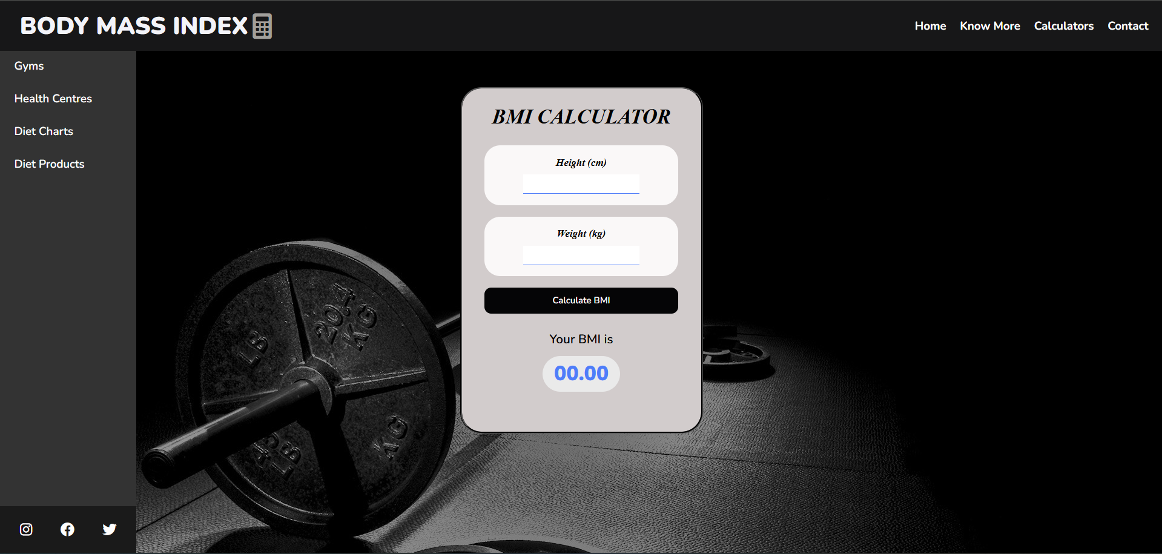

**6. Sidebar Navigation**

The sidebar offers links to **additional resources** like gym directories, health centers, diet plans, and diet products, enhancing the overall user experience.

**Visual Example**:

**7. Dropdown Menus**

The navigation bar includes dropdown menus for other related tools like **BMR Calculator** and **Body Fat Calculator**.

**Visual Example**:

**9.Conclusion with Future Scope**

* User **Profiles**: Add account creation and BMI history tracking over time.
* Multi**-Language Support**: Translate the interface to make it globally accessible.
* Mobile **Application**: Create a dedicated app for offline usage and push notifications.
* AI **Integration**: Offer personalized health insights and diet/workout recommendations.
* Gamification: Introduce challenges or rewards to motivate users to monitor their health consistently.

**Conclusion**

The BMI Calculator is a simple yet impactful tool for health monitoring. By simplifying BMI calculation and categorization, it encourages users to take ownership of their health. With further enhancements, this tool can evolve into a comprehensive health management platform.

**10. LIST OF REFRENCES**

* **W3Schools - BMI Calculator:**

<https://www.w3schools.com/howto/howto_js_bmi_calculator.asp>

* **CSS Tricks - Flexbox Guide**:

<https://css-tricks.com/snippets/css/a-guide-to-flexbox/>

* **GIT-HUB – BMI REPOSITRIES**

<https://github.com/SwamiTheDev/BMI-Calculator>

* **GeeksforGeeks - BMI Calculator with JavaScript:**

<https://www.geeksforgeeks.org/bmi-calculator-in-javascript/>